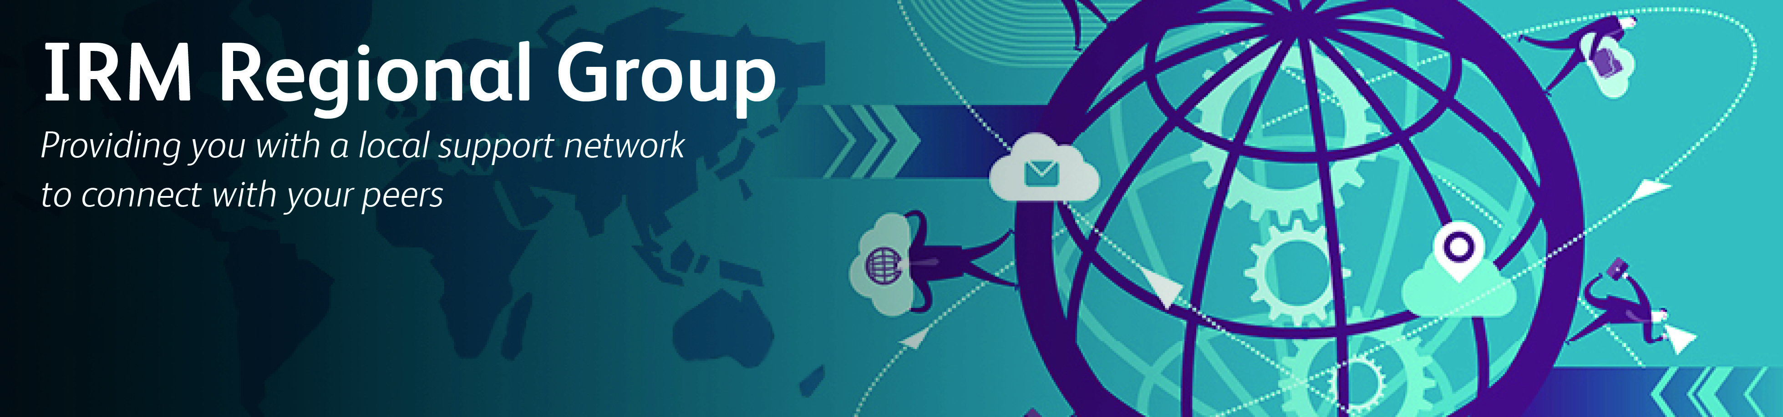

IRM ZIMBABWE REGIONAL GROUP 13 JULY 2018
MEETING REPORT

1. Introduction and Updates
The Zimbabwean Regional Group met at Telone Centre for Learning for a half day workshop on the 13th of July 2018. The number of attendees grew from 10 to18 compared with those that attended in the previous meeting held on 13 June 2018. A brief background of the Zimbabwe Regional Group was given and members were encouraged to become fully paid up members of the IRM Global. The meeting was also briefed on the initiatives planned for the growth in membership of the IRM Zimbabwe Regional Group and on upcoming events in September and November 2018.

2. The Presentation: Integrating ERM into Business Operations
Dr. Stanely Mutenga a renowned risk professional presented to the Group on the topic “Integrating ERM into Business Operations”. Dr. S. Mutenga is a Fellow of the Institute of Risk Management. He is also the Executive Director of Starz Risk Solutions & Kkidz Media, an external examiner in Insurance and Risk at National University of Science and Technology Zimbabwe, Peer Reviewer of Geneva Papers on Risk and Insurance, visiting assistant Professor at Glasgow Caledonian University and University of Zambia.
Dr. Mutenga’s presentation was the main highlight for the day focusing on implementing a successful ERM program.
3. Key highlights of the presentation
- Link between ERM and business
- Governance
- The operating model and its purpose
- How ERM affects strategy
- Risk, strategy and objective-setting
- Linking Strategy to the Risk Management process
- Linking objectives to strategies to risks to KRIs
- The strategy map
- Executing risk in execution
- Risk information, Communication, and reporting

4. Lessons Learnt
- Enterprise Risk Management is integrated with all other aspects of the business, including governance, strategy, performance management, and internal controls
- An Operating Model is critical for an organisation to effectively deliver its business strategy. It takes the key strategic imperative and defines how the business will organise itself to succeed. An Operating Model presents a coordinated view of a business. It should be analysed and developed across multiple dimension
- Enterprise Risk Management affects Strategy. Strategy must be linked to Risk Management Process. It helps an organization to identify and assess risks that may affect an entity’s ability to achieve its strategy and business objectives.
- ERM is integrated into the company’s strategic plan through the process of setting strategy and business objectives. Objectives must be linked to strategies, risks and key risk indicators.
- KRIs provide opportunities for proactive strategic Risk Management. A well-designed ERM system provides information that allows management to understand whether key strategic objectives are being met and to identify opportunities to adjust strategies and tactics to take advantage of shifts in the environment that might be exploited for the benefit of the organization and its stakeholders.
- ERM prioritises risks according to their severity and considering the entity’s risk appetite.
- ERM allows selection of risk responses and it also assist in monitoring performance for change.
- Communication is critical in implementing a successful ERM program. Communication must be continual and iterative throughout the entire organisation.
- Management uses relevant and quality information from both internal and external sources to support enterprise risk management. A well-designed ERM system provides information that allows management to understand whether key strategic objectives are being met and to identify opportunities to adjust strategies and tactics to take advantage of shifts in the environment that might be exploited for the benefit of the organization and its stakeholders.
- Successful implementation of ERM enables the organization to report on risk, culture, and performance.

